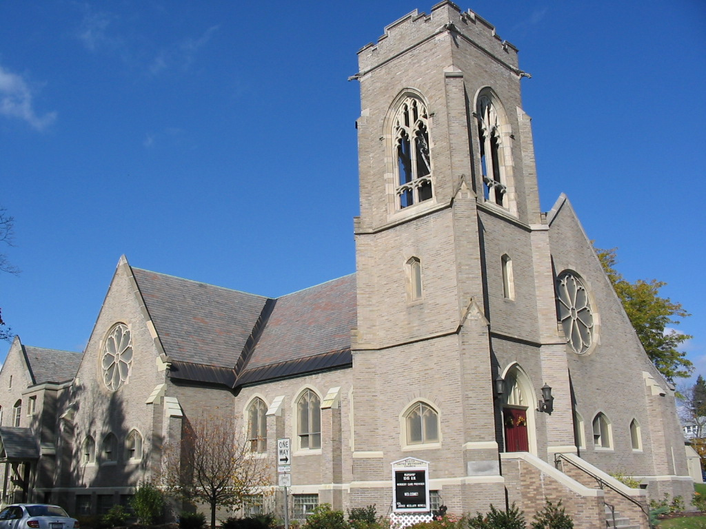
MAY 2016
MAY 2016
“For all who are led by the Spirit of God are children of God.” – Romans 8:14

Lead Me, Guide Me

The Easter Season leads us into the month of May and the Season after Pentecost leads us out…

As I looked over the calendar for this month, I
noticed an overall theme of leading and guiding.
We begin the month recognizing our Scouts and
the Leaders that guide them both current and former.

In addition, some of us have taken the lead on recruiting folks to participate in the Schenectady CROP Walk on Sunday, May 1st. While there are others who are participating in a 5K run/walk with Girls On The Run, an organization which guides
girls to a healthier lifestyle, on May 8th.

This brings us to the third Sunday of the month,
the Day of Pentecost, where we recognize that
Jesus sent the Holy Spirit as a guide to help lead and form us into modern day disciples tasked with not only doing his work but “greater works than these.”
– John 14:12

“Before the Spirit came,
you were just words on a page,
Black on white and yellowed with age.
Simply a story of long ago,
Of a man who had so much love to show;
Who healed the sick and cured the lame;
Took our guilt and bore our shame.
It sounded so good, but it just couldn't last.
It was not for today but locked in the past.
Until the Spirit came.

Now the Spirit has come,
you are here at my side,
Larger than life and ready to guide;
Making real to me all that you said
And doing through me the things that I read.
I am the glove that your hand has filled;
I am the cup into which you have spilled
All the love and the power
which you promised would come,
Right now in the present and for everyone.
Since the Spirit came.” www.barnabasinchurches.org.uk

In Christ’s Love,
Pastor Margaret Currier
518-372-9575 – church
518-688-9515 – parsonage
PastorMargaretC@outlook.com
Scotia
UMC

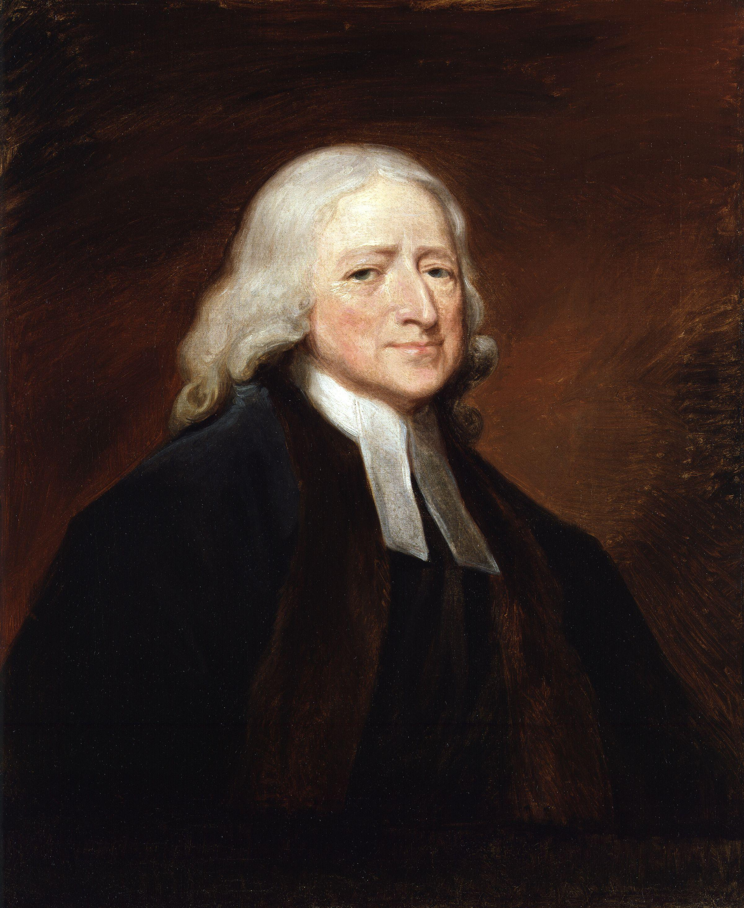 Wesley’s Wisdom
From John Wesley’s Sunday Service of the Methodists in North America
“Almighty God, unto whom all hearts be open, all desires known, and from whom no secrets are hid; cleanse the thoughts of our hearts by the inspiration of thy Holy Spirit, that we perfectly love thee, and worthily magnify thy holy Name, through Christ our Lord. Amen.”

Worship Schedule

Liturgists Sound
5/1 David Burhmaster Mark Cieslak
5/8 Marcia Smith Dave Read
5/15 Scott Brady Bob Hatt
5/22 Dean Goodell Don Smith
5/29 TBA Mark Cieslak

Greeters Counters
5/1 Daly family Judy Swain, Jill Wesley
5/8 Holly Russo, Deb Cieslak
5/15 Clarence Mosher, Darlene St. Amour
5/22 Carol Jacobson, Deb Cieslak
5/29 Fran Brown, Deb Cieslak

Ushers Social
5/1 Ian DeSorbo, Mark Cieslak Charlene Vice, Ava Goodwin
Laurie & Ella Peconie
5/8 Don Smith, Steve Wesley Men’s Group
5/15 Dick & Pat Knapp Flansburg family
5/22 Darlene St. Amour, Sally Dean, Holly Russo
Royann Rogerson
5/29 Martha Hatt TBD

Acolytes
5/1 Rebecca Currier, Hailie St. John
5/8 Kaleb Graves, Kayden Graves
5/15 Alec Flansburg, Zoey Flansburg

The Women’s Group

SUMC IN MISSIONS

Scotia Glenville Food Pantry 2nd & 4th Sundays of the month.
-Go through your pantry and lend a helping hand-

Thank you– keep bringing in those bottles and cans, Box Tops for Education, and Labels for Education. Please take the time to cut them out and bring them in.

Regional Food Bank – We will be meeting in the church parking lot at 2:00 pm on Tuesday, May 17th to volunteer at the Food Bank.

-Jill Dunster-Wesley (cell) 423-3546 (home) 372-4047 jldunster@hotmail.com



Support the 2016 Schenectady Crop Walk that will be held on Sunday, May 1, 2016. Last year, our local crop walk made $47,704.00 to help fight community hunger. Please consider walking or making a donation for this event. Contact Deb Cieslak at dcies4183@aol.com or Sue Van Vorst for further information.

Please go to crophungerwalk.org and search for Scotia United Methodist Church team to sign up to join the team or donate to sponsor us in this very important walk. Thank you for helping to end hunger one step at a time!

Women’s Group- May 9th at 7:00 pm in the Fireside Room. Special guest, Lynn Streifert, will teach the art of card making. Attendees will be given four cards (to keep) for a small fee of $5 to cover all the supplies. Please RSVP as she needs a final number to bring enough supplies.

Confirm attendance with either Sue Sykes (ssykes12302@outlook.com), Royann Rogerson (rmtr22@aol.com), or Wendy Liebl (wliebl@nycap.rr.com) Refreshments will be served.

Rummage Sale dates this year will be June 3rd and 4th.

Church Treasurers Report
31-Mar-16
 |  | 2016
 |  | March | Total thru
 |  | 2016 | 3/31/2016
 | Individual Contributions | $10,979 | $32,962
 | Building Use/Rent | 1,625 | 5,536
 | Fund Raising/Interest Income | - | 174
 | Other Designated Giving | - | -
 | Total Operating Receipts | $12,604 | $38,672
 | Wages & other employment expenses | $6,485 | $19,772
 | Church Operations/Program | 325 | 1,607
 | Parsonage Expenses | 563 | 2,623
 | Church Building-Repairs/Safety | 1,085 | 1,901
 | Church Building-Utilities/Water | 1,168 | 3,324
 | Church Building-All Other | 1,307 | 2,500
 | Apportionments | 2,142 | 6,876
 | Benevolences | 96 | 190
 | Total Operating Expenses | $13,171 | $38,792
 | Shortage | -$567 | -$120
 | There was a shortage of ($567) for the month of March 2016.
 | Year to date shortage through March 31, 2016 is ($120).
 | If there are any questions or requests for detailed information,
 | please contact Mary Connors at mechardball@yahoo.com.


Cynthia will be away May 24-26 and May 31-June 1 for her Christian Writer’s Conference.



- The children have been studying “The Beatitudes” in April with lessons focusing on Spiritual Humility, Character and Strength.

- The month of May will bring “The Life of Joseph” (including the coat of many colors!)

- We are working on plans for Children’s Sunday which will be on June 19th. Please mark your calendars and save the date!

- Are you in 2nd -12th grade and don’t have your own personal Bible? Please let us know by contacting the office at 372-9575 or scotiaumoffice@gmail.com. You will receive your very own Bible to keep when we present them on Children & Youth Sunday, June 19th.

- Attention all high school seniors: if you are graduating from high school this year, please let us know so we can congratulate you!

CALENDAR
5/1 Scout Sunday, Communion, Crop Walk
Staff Parish Relations Meeting after service
5/2 Trustees Meeting 7 pm
5/5 Choir Practice 7:30 pm
5/8 Mother’s Day
5/9 Women’s Group 7 pm
5/15 Worship/Welcoming Meeting after service
5/17 Regional Food Bank 2 pm
5/18 Finance Meeting 7 pm
5/19 Choir Practice 7:30 pm
5/23 Admin. Council Meeting 7 pm
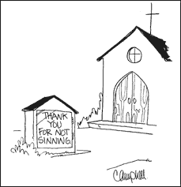

Visitation

One of the things that had to change when Scotia UMC went to a part-time pastor is the church’s visitation program. Gone are the days when the pastor did all the visiting. Gone are the days when hospitals called the church to tell us a member was in the hospital. The Health Information Patient Privacy Act (HIPPA) took care of that.

Now are the days when the congregation has to step up and take on some of what were always thought of as pastoral duties. To that end, when I came to Scotia I offered training in how to do visitation and agreed to oversee the visitation program. We now have a small group (7 or 8) visitation volunteers who will do routine visits - periodic visits to nursing homes and home-bound members. We have a list on the wall in my office of those we thought needed visits on a long-term basis. Feel free to suggest other names to me or any of the visitation crew. (I’ll post their names by the list.)

When a pastoral visit is needed, I am the backup to Pastor Margaret.

Of more concern are those who might like a visit who are not on that list. Thus the following suggestions:
- Reading minds is not a pastoral skill. If someone is out for a short period, we may not know. I know we all think that if we miss church for a Sunday or two, someone will surely notice! Not true. If you are out and would like a visit, please call the church and let us know. If you notice or know that someone has been missing for a bit, please let us know.
- If someone is in the hospital, please let us know ASAP. Even in the days when hospitals called to let us know, we often didn’t get the news until after the fact. Both Margaret and I respond quickly in these cases.
- If a pastoral visit is desired, there are three routes to have that happen:
  - When a member of the visitation team comes to visit, tell them you want to see the pastor.
  - When a member of the visitation team visits, they may decide - whether you request one or not - that a pastoral visit is in order.
  - Call the pastor directly.
- If it’s an emergency, leaving a message on the church phone (or worse yet, calling the church phone and NOT leaving a message) will not work. Call Pastor Margaret or me directly (my cell is 322-1179).
- Anyone coming to visit, unless you have invited them, is supposed to call ahead for permission to visit. If they can’t reach you on the phone, they are not to visit.

I hope this information is helpful and informative regarding our visitation procedures.

-Carl Shepard

