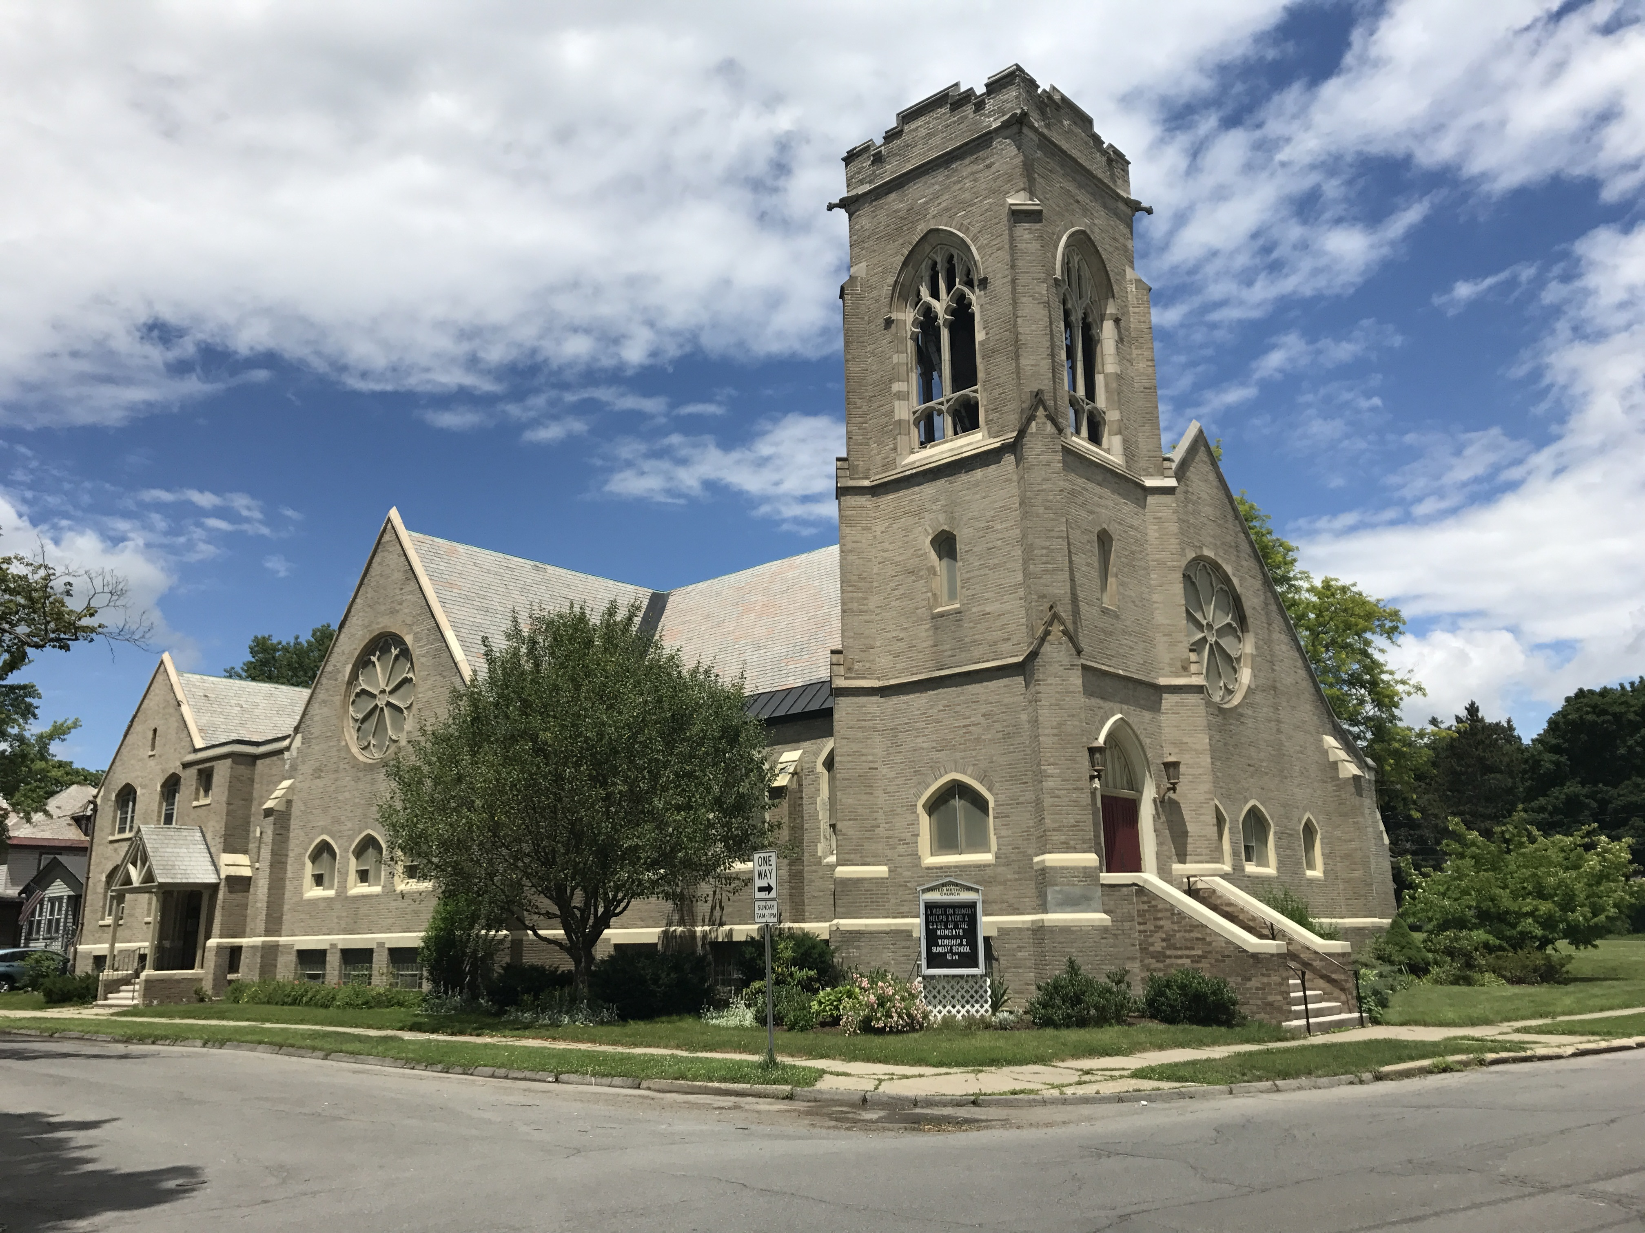
SUMMER 2018



Office Hours for July/August: Wed. 8-4 and Thurs. 9-1.

It’s finally summer! Complete with sunny skies and warm weather. Actually, hot weather but who’s complaining? It still is better than snow, ice and frigid temps. Enjoy your vacation time and the brighter days while they last.

Because summer is short, it is much quieter here at SUMC as people are traveling more during this time. But we still need to know of any meetings or events scheduled for the future. Please stay connected and send your information to scotiaumoffice@gmail.com
The Weekly Wakeup is taking a seasonal break but we can send out important announcements as needed.

Thank you to Living Gospel Ministry for their recent visit. On July 29th we will have a special surprise preacher. Hint: I am his biggest fan, he plays a mean sax and it is sure to be a lovely time for all : ) - Cynthia

Community Breakfast - We served 82 people at our last community breakfast held in June. Our next breakfast and bake sale/soup sale will be September 22nd. The breakfast hours are 8-11 a.m. and the bake sale/soup sale is from 8-noon. We have pint and quart plastic containers with lids, available from Jill Wesley.

I would encourage everyone to participate in some way. I started out donating to the bake/soup sale and then helping with the set-up of the dining room the day before. My lovely assistant, June Pelham and I organize and run the sale now with other volunteers and the money evolved from going into the Mission coffers to paying for the groceries for the free breakfast, so it’s a win-win situation!

Please find it in your hearts (and schedules) to come for breakfast and/or make some goodies to sell and take some treats and really good soup home with you. Get this date circled on your calendars!
–Holly Russo

Scotia
UMC

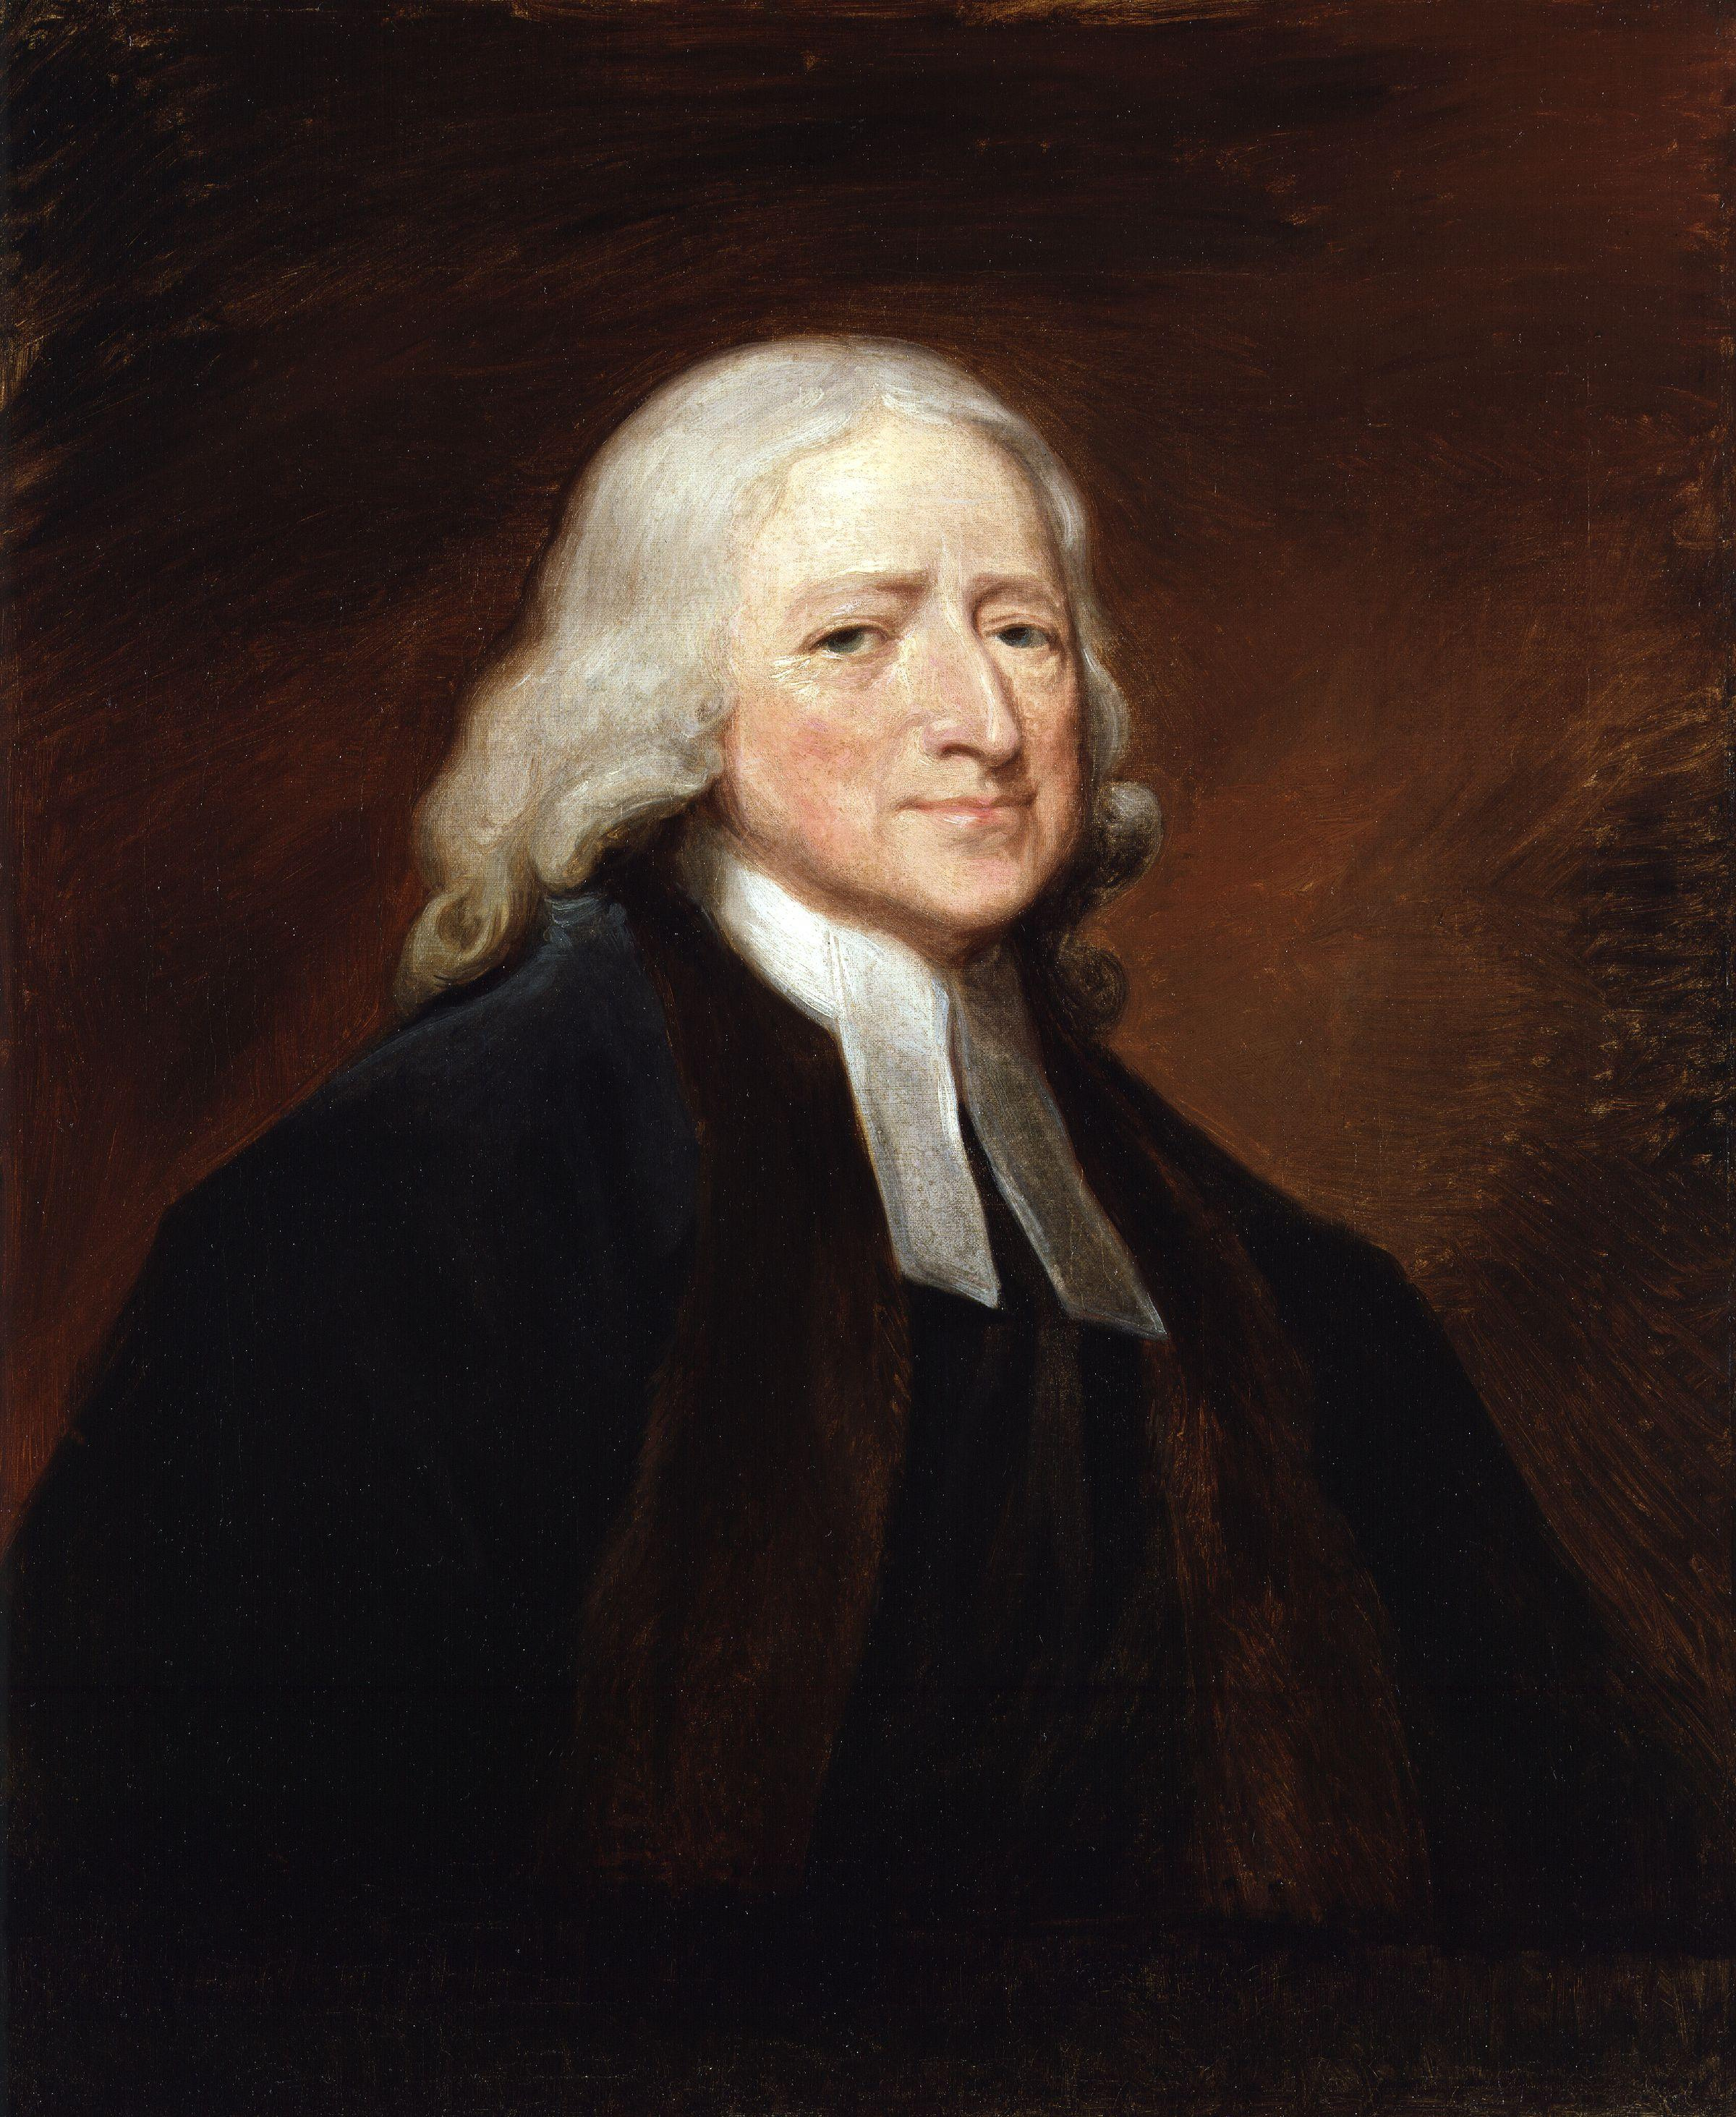 Wesley’s Wisdom 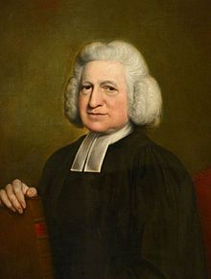

The curmudgeonly Samuel Johnson (1709-1784) had mixed feelings about the Wesleys. He knew John at Oxford, and said of him, “John Wesley’s conversation is good, but he is never at leisure. He is always obliged to go at a certain hour. This is very disagreeable to a man who loves to fold his legs and and have out his talk, as I do.” (Did You Know? Christian History magazine, issue 69)

Worship Schedule

Liturgists Sound

7/1 Steve Long 7/1 Steve Long
7/8 Belinda Wagner 7/8 Bob Hatt
7/15 Wendy Liebl 7/15 Jim Coburn
7/22 Steve Wesley 7/22 Mark Cieslak
7/29 Cynthia Lovely 7/29 Steve Long

Ushers & Greeters

7/1 Wendy Liebl, Barb Hanley
7/8 Deb Cieslak, RoyAnn Rogerson
7/15 Jill & Steve Wesley
7/22 Sue Sykes, Megan, Dara
7/29 Carol Jacobson, Jill Wesley

Counters Social
Pat Knapp, Tim Keegan 7/1 Sue Sykes & Megan
7/8 RoyAnn Rogerson
7/15 Wendy Liebl
7/22 & 7/29 TBA

------------------------------------------------------------------------------------------------------------------------

SUMC IN MISSIONS

Regional Food Bank – Volunteers, please meet at the Food Bank at 2:30 pm on Tuesday, . If you need to carpool, contact Dick Knapp at 518-393-5737.
-Jill Dunster-Wesley (cell) 423-3546 (home) 372-4047 jldunster@hotmail.com

Carl Shepard has been duly licensed and appointed as quarter-time pastor to Scotia UMC, and will be with us until a permanent half-time pastor is assigned by the District Superintendent. He is no stranger to us, having served here as assistant to the pastor for over two years during 2015-17.
Carl comes from a background in education and the church. He holds four degrees (BS, MS, MS, PhD) and was half way to the M Div when it became apparent that finishing on a part-time basis would coincide with his planned retirement. He taught high school in Newcomb for 14 years, then was a professor and administrator at SUNY Cobleskill for 20 ½ years before entering ministry. He served churches in Schenectady, Rotterdam, and Alplaus for ten years before coming to Scotia the first time. In retirement he joined Calvary UMC in Latham where he has been quite active. He still has a few commitments there which he will be honoring this year.
Carl is a singer, a deep bass. You’ll hear him on Sundays, usually singing the bass part to the hymns. He has sung in church choirs and a number of other musical groups. Even a couple of musicals. He is scheduled to sing with the Calvary choir at Carnegie Hall next Memorial Day weekend. In his spare time he has gotten involved in disaster response work. He spent over six years helping with flood recovery in the Schoharie valley, has been on several Volunteers in Mission (VIM) trips and Early Response Team (ERT) trips doing flood recovery work. He is in the process of becoming an ERT trainer and hopes to teach a class in the fall.
Carl and his wife Johanne live in Clifton Park. They have two sons - Christopher and husband Chris live in Connecticut, Jeremy and husband Jonathan live in Manhattan. Pastor Carl was privileged to conduct both their weddings.
Carl is looking forward to becoming re-acquainted with the people of Scotia UMC. (But he’s terrible with names, so please be patient with him.)
– submitted by Pastor Carl


#37 “Fill My Cup, Lord”
This was written by Richard Blanchard in 1953. He was suffering from limited lung capacity and it was a burden he had to deal with. He was pastor of a church in Coral Gable, FL and one day while he was waiting for a young couple to come for an appointment he told his secretary he was only waiting 30 minutes and went into one of the Sunday School rooms and sat down at the piano to while away the time. In less than 30 minutes God gave him this inspiring song. He later said, “When I was not in the mood to be used by God, God was in a mood to use me.” As Richard Blanchard looks back over his life he declares “that even though God chose in his providence to impair my physical being, he has in so many other ways ‘Filled My Cup.’”
-submitted by Holly Russo

R.O.P.E.
A strong rope is a valuable piece of equipment for any mountain climber. It helps him reach his goal safely. Each day we face many mountains in our lives. God has provided a lifesaving rope that, once we grab hold of it, will guarantee us reaching our heavenly destination. Jesus Christ is that Rope. Every morning let your Rope guide you by remembering this:

R ead God’s Word.
O bey God’s Word.
P ray to your heavenly Father.
E njoy God’s purpose for you every day.
- Lori Boruff

Prayers & Celebrations

For those of you who remember Alan & Janet MacHattie who moved to Kentucky several years ago: Janet died in the month of May. If you’d like to encourage Alan with a note or card the address is:
70 Blevins Rd., Liberty, KY 42539. Please keep the family in prayer.

Also, pray for Jan Rowell who recently lost her father. Her address is: 9 Van Buren Rd., Albany, NY 12206.

We celebrate the baptism of Samantha Pryor, the daughter of Robert & Kim Pryor, on June 3, 2018.



Pastor Carl plans to be in the church office on Tuesdays for about two hours each week between 11 am to 1 or 2 pm. Please call ahead of time to be sure of his schedule if you’d like to stop in and see him.
Phone: 518-322-1179 OR Email: umccarl@nycap.rr.com

The next newsletter will be the September issue.
Please send all information to scotiaumoffice@gmail.com by August 20th.

Church Treasurers Report
1-May-18
 |  | Total thru
 |  | May-18
 | Individual Contributions | $45,780
 | Building Use/Rent | 12,052
 | Fund Raising/Interest Income | 662
 | Other Designated Giving | (110)
 | Total Operating Receipts | $58,384
 | Wages & other employment expenses | $33,585
 | Church Operations/Program | 4,260
 | Parsonage Expenses | 7,954
 | Church Building-Repairs/Safety | 2,175
 | Church Building-Utilities/Water | 8,608
 | Church Building-All Other | 4,480
 | Apportionments | 1,342
 | Benevolences | 77
 | Total Operating Expenses | $62,481
 | Shortage | $ (4,098)
 | There is a shortage of ($4,098) through May 2018.
 | If there are any questions or requests for detailed information,
 | please contact Mary Connors at mechardball@yahoo.com.

We finished up another wonderful Sunday School year on June 17th when the children & youth led the Children's Sunday service with a focus on "Women of the Bible." It was a great opportunity for the students to share with the congregation what they had been studying all year. They did a great job!

Everyone is now enjoying the summer and we will "gear up" in September for another eventful year (we already have lots of ideas!).

